Project Design Phase-II
Technology Stack (Architecture & Stack)

Date | 14 APRIL 2025
Team ID | SWTID1742640402
Project Name | MyRide
Maximum Marks | 4 Marks

Technology Stack
To build a scalable, secure, and high-performance Cab Booking App, we carefully selected the following technologies based on project goals, team expertise, and industry standards.
1. Frontend (React.js)
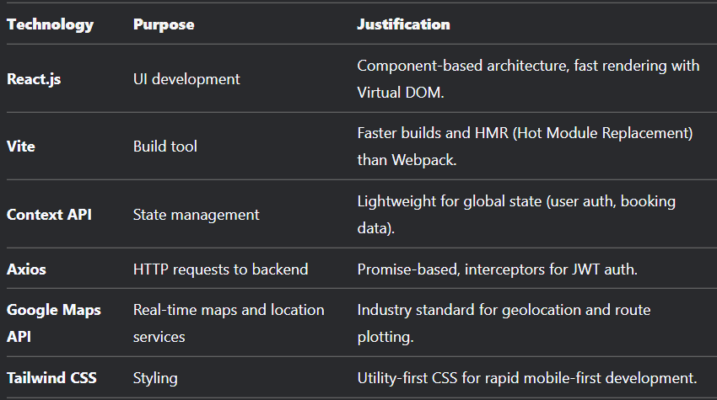

2. Backend (Node.js + Express.js)
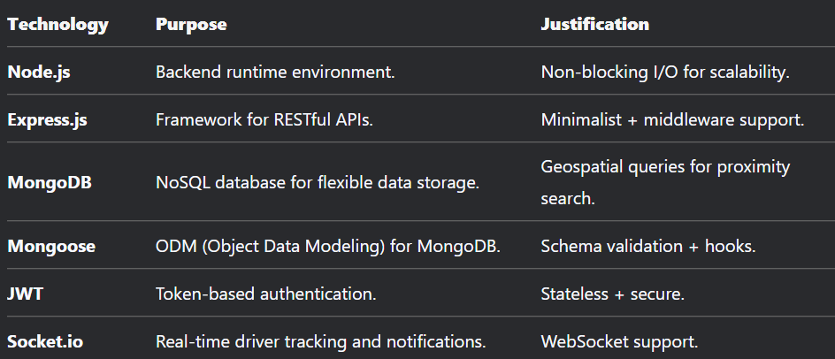

Why This Stack?
- Performance: React (Virtual DOM) + Node (non-blocking I/O) ensure speed.
- Scalability: MongoDB sharding + Redis caching handle growth.
- Safety: JWT + HTTPS + rate limiting for secure APIs.
- Cost-Effective: Open-source tools reduce licensing costs.

